**WinPro Quick Start Guide for Small Systems**

**STEP 1: SQL Installation**

You may skip this step if your server PC already has Microsoft SQL (Microsoft SQL must be version 2008 and above). You need to get know the User ID and Password for the Microsoft SQL login. Then, proceed to WinPro Installation.

If your server PC does not have Microsoft SQL, you may need to install Microsoft SQL into your server PC. You may download the SQL installer and SQL Installation guideline from ELID Tiki Support website as link below

<http://www.elid.com/support/tiki-index.php?page=SQL+2008+R2+Installer>

There are two installer files inside the folder and please choose according to your server PC specs.

SQLEXPRWT_x64_ENU.exe – for windows 64 bits

SQLEXPRWT_x86_ENU.exe – for windows 32 bits

Follow the guideline until the end. The guideline is for server PC that clean from any Microsoft SQL.

**STEP 2: WinPRO Server Installation**

Install the WinPRO server at your server PC, you may download the latest installation file from Tiki Support website as link below

<http://www.elid.com/support/tiki-index.php?page=WinPro+SQL-based+Access+Manager>

|  |  |
| --- | --- |
| Minimum Server Requirements | |
| Processor:  Operating System:  RAM:  Disk Space Required:  Monitor Resolution:  USB Port:  Interface: | Intel Core i3 @ 3.50Hz  Microsoft Windows Server 2003  4GB  320GB  1024 x 768 pixels, 16-bit colour  1 (for Software License)  Keyboard and Mouse |

The installation file name is wp_inst_xxxxx.exe. Run the installation, at the ODBC Setup screen, Enter the Server Name (your PC name or ‘local’), login name is ‘sa’ and password is elidstrongpw (This is password that was created under SQL installation guideline. It might be different if you have existing Microsoft SQL).

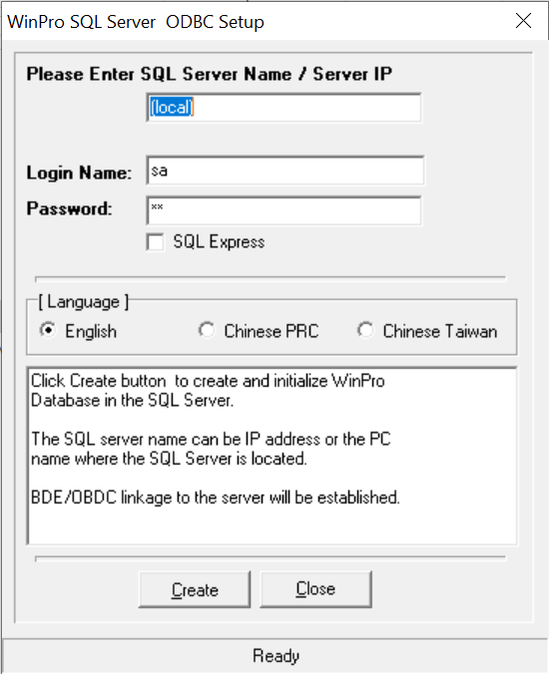

Once you have successfully installed WinPRO, there are three programs in the WinPRO software:

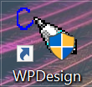

**WinPRO Designer**

Configure the system, such as controller unit number, floor plan, etc. Normally just need it once a while when adding / removing controllers from the system.

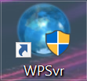

**WinPRO Server**

Responsible to retrieve transactions and issue commands to the controllers.



**WinPRO Client / Manager**

Manage all the door access related operations, most of the time, you will be using Manager.

**STEP 3: Hardware Setup**

Follow the wiring diagram that has provided in the packaging box. If you are using serial communication you may need to connect communicator to the PC. Each communicator can be up to 16 doors by daisy-chain connection.

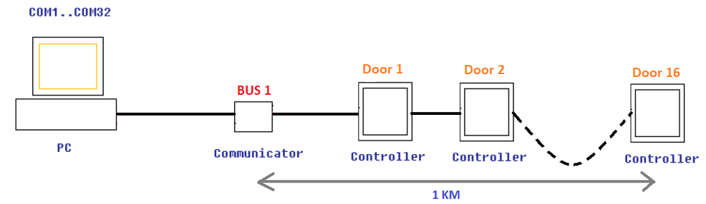

Serial communication: Daisy-chain connection

If you are using TCP/IP you may need to connect the PC to the nearest switch/hub that linked to the controller.

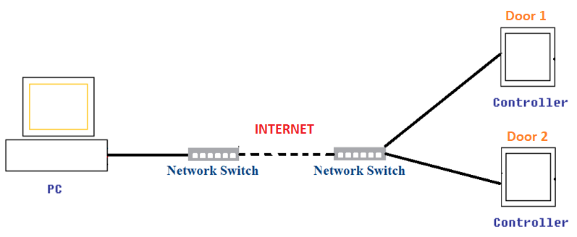

TCP/IP Communication

Then, get setup your controllers with proper unit number and baudrate (if you are using serial communication) or IP Address (if you are using TCP/IP communication).

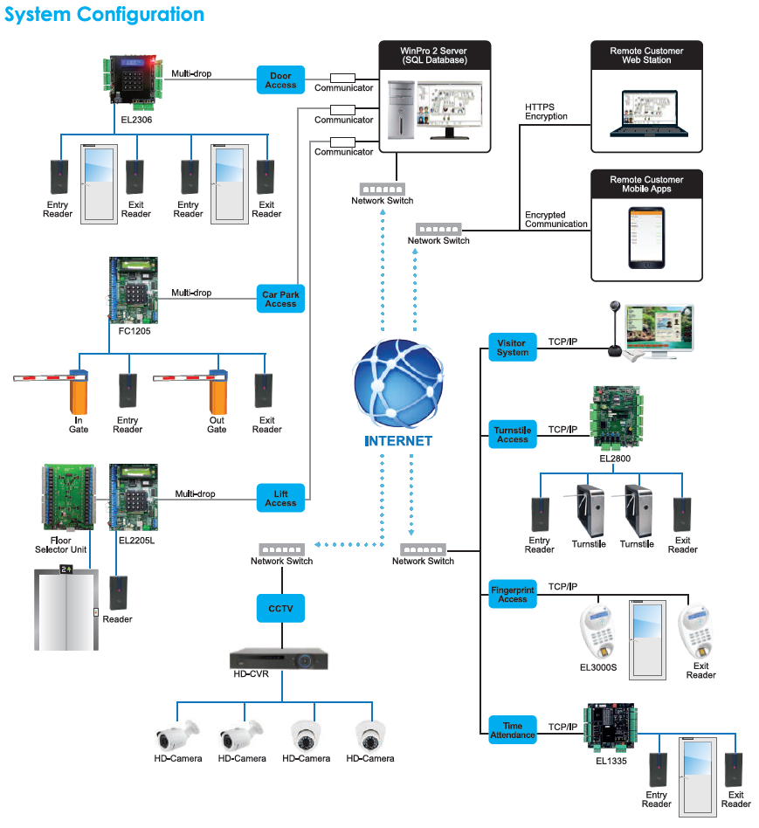

WinPro System Configuration

**STEP 4: Software license**

Number of doors that can be added in WinPro is determined by software license. ELID supply different package of WinPro. If you run WinPro software without license key (demo mode), you will only be allowed to control one door with 50 users. For multi doors and users, you will require to purchase software license.

Please ensure that the license key is attached to the PC. It should be connected to PC’s USB port.

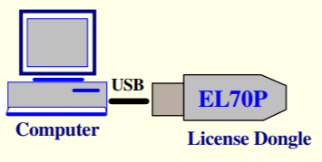

After plugged-in the license key, you have to install the driver of the key from the CD in the box. Once the driver has installed, PC will assign port number to the key. You may check the port number under Device Manager. For example, see figure below, the port number of the EL70P license key is COM3.

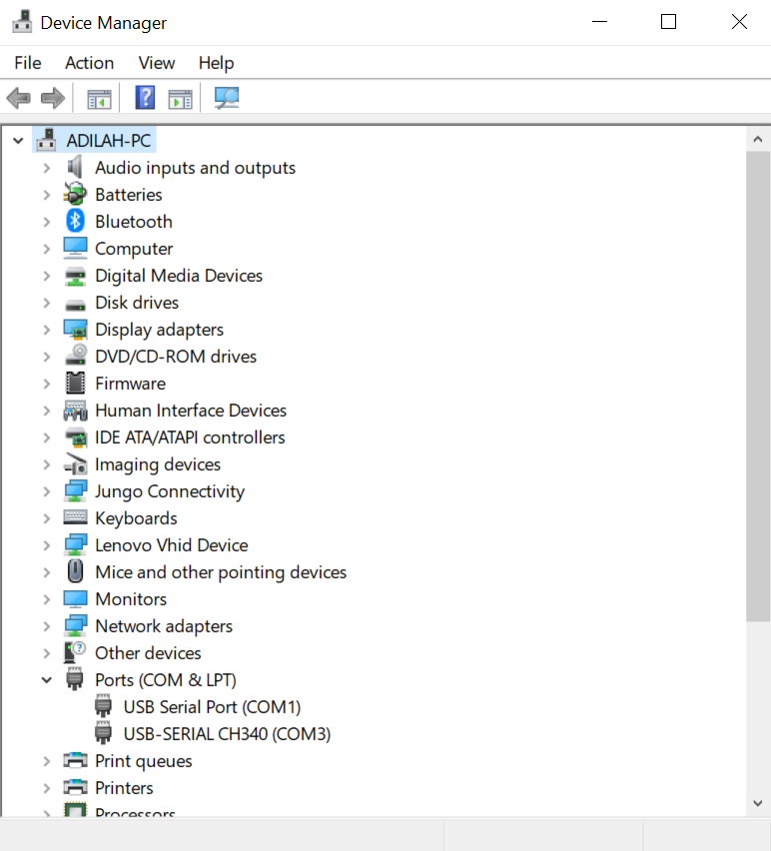

**STEP 5: Setup WinPRO Designer**

Run WinPRO Designer, once key detected, you will be prompted to enter ‘User ID’ and ‘Password’, both the default user ID and password is ‘ELID’.



Once log in, you will see the WinPRO main screen as follow:

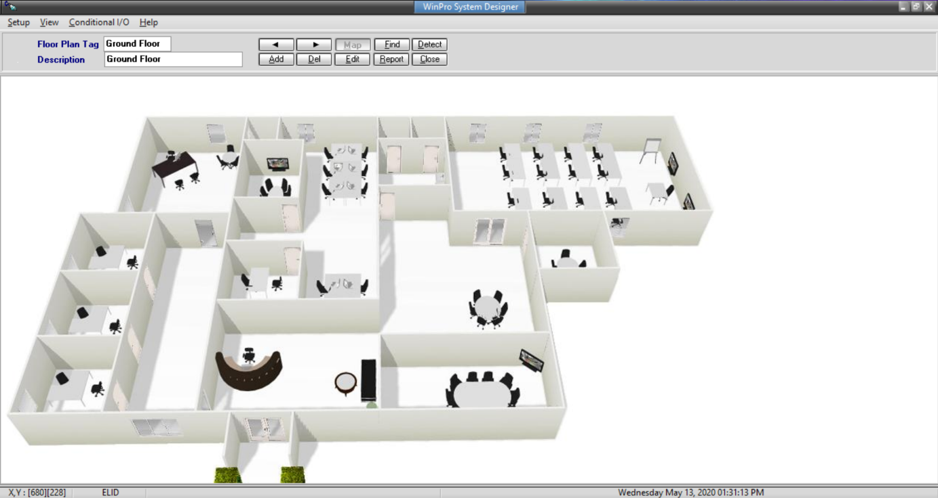

**Add New Controller**

You can add new controller at the WinPRO Designer. To do this, you can either right mouse clicks at the floor map or go to Setup -> New controller.

1. Change the description of the controller
2. Define the ‘Logical point’ of the controller *(this logical point has to match with the unit number set in the controller, each controller MUST have identical logical point)*
3. Select ‘Controller Type’

* EL363 select EL360
* EL374 select EL370
* EL1335 select EL1330
* EL1375 select EL137x
* EL2305 select EL23xx
* EL2306 select EL2307A (Door 1), EL2307B (Door 2)
* EL2800 select EL2800A (Door 1), EL2800B (Door 2), EL2800C (Door 3), EL2800D (Door 4)
* EL2305L select EL2305L
* FC2305/6 select FC1000
* EL3000S select EL3000

1. Select ‘Area In’, ‘Area Out’ and ‘Location’ of the controller.
2. Enter the controller’s IP Address if the controller run at TCP/IP
3. Click ‘OK’
4. You can drag the controller icon at the right position

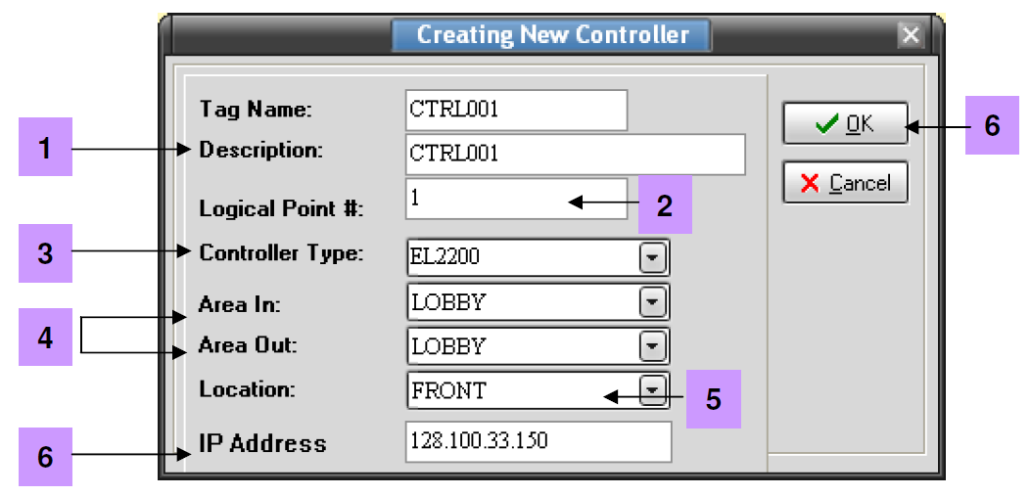

**Detect Controller**

Once you have successfully setup the system, you can now test the connection of each controller to the software by using <Detect Controller> feature at WinPro Designer.

Click the ‘Detect’ button at the top panel of E.WIN Designer, screen below will be shown:

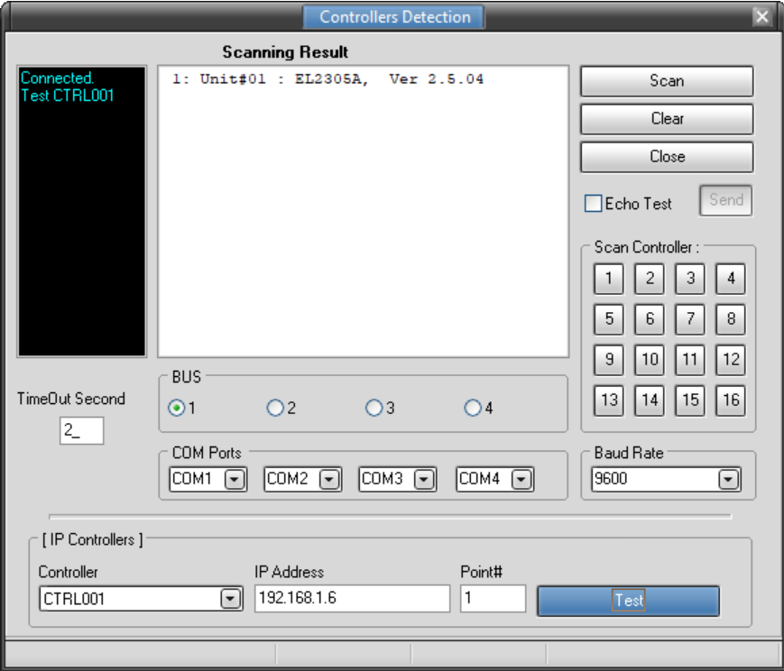

**4**

**5**

**6**

**3**

**1**

**2**

**Serial Communication**

1. Enter the COM port number for Bus 1. For example, in figure below the port number of Bus 1 is COM1.

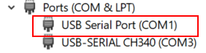

1. Select Bus 1.
2. Click scan button, all the detected controllers will be listed down on the scanning result screen. The controller will reply with the controller model and also firmware version, otherwise it will show no reply.

**LAN Communication**

1. Select the controller to be detected from the drop-down list.
2. The IP address and the logical point number of the relevant controller will be displayed.
3. Click ‘Test’ button to check its connection, the status of the controller will be shown on the scanning result screen.

If scanning result screen show no reply, it means that PC could not reach the controller. Please do some steps below to resolve the issue:

1. Check unit number and baud rate at controller, make sure it has set correctly.
2. Please ensure 12V power is connected at communicator if use Multidrop communication.
3. Please ensure jumper selection (RS485/Multidrop/LAN) has set correctly at controller board.
4. Please ensure communicator/LAN module working well.
5. Please ensure COM Port/IP Address has set correctly.

**STEP 6: Startup WinPRO Server**

Double click the icon on the desktop to start WinPRO Server. You will be prompted for login. Enter ‘elid’ for both User ID and Password:

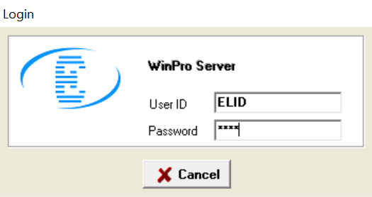

Confirmation box will be prompted to configure license USB port number. Click ‘Yes’ to continue.

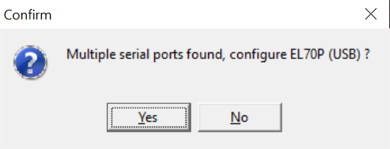

Enter the COM port number for license EL70P that you get in STEP4 which is COM3. Tick ‘Do not show this’ if you want to skip this configuration for next login.

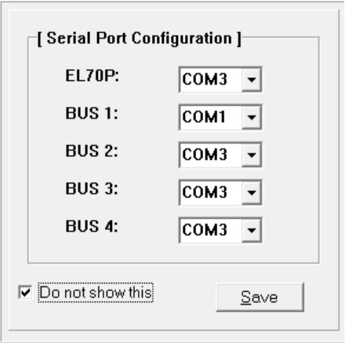

Click ‘Save’ and the main screen for WinPRO server will appears:

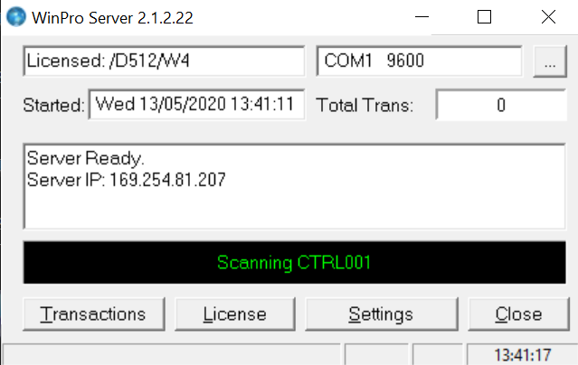

WinPRO Server handles license key detection, transaction retrieval and communication between the access controllers and the WinPRO Clients.

**License Key Activation**

If you are 1st time using WinPRO, you may need to activate your license key; else, the software will be expired after 30 days.

1. Click on ‘License’ button.
2. If key is detected, key serial number will be shown at the screen
3. Enter the 16-digit activation code which is at the small slip that provided with the license key.
4. Click ‘Upgrade’ button to activate.

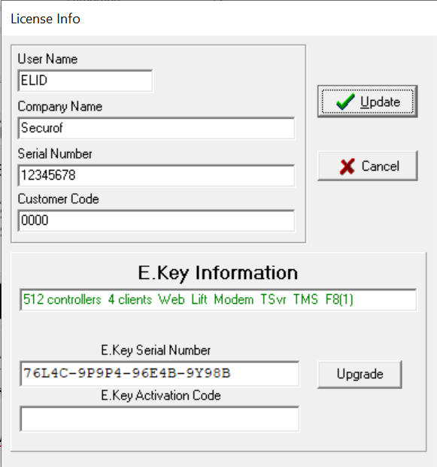

**4**

**3**

**2**

**STEP 7: Log in WinPRO Manager**

With WinPRO Server installed and running with a valid license key, now you are ready to proceed to run WinPRO Manager. Enter ‘elid’ for both User ID and Password when asked.

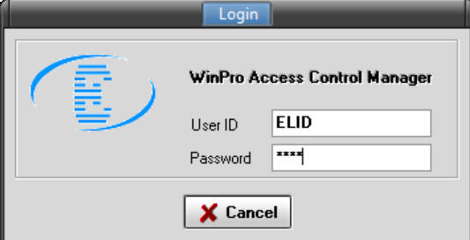

Below is the WinPRO main screen.

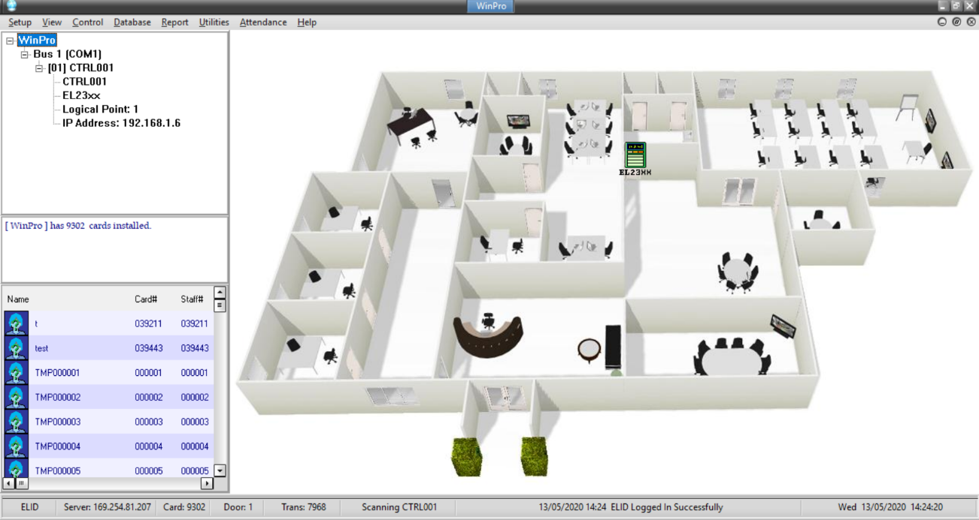

Pull Down Menu

* Consist of ‘Setup’, ‘View’, ‘Control’ ‘Database’, ‘Report’, ‘Utilities’ and ‘Help’

Tree View Pane

* Showing controllers grouped under each of the buses in tree layout.
* Message area to give additional information, such as total number of cards in a selected controller.
* Photo list to show thumbnails of the card holders whose cards are installed in that particular controller.

Floor Plan Pane

* Display floor plan with dynamic icons representing the controllers.

Status Bar

* Display User, Server IP Address, Total Cards, Total Controllers, Total Transactions, Scanning Status, Online Status and current date/time.

If controller down, the controller icon will change to  . This means software fail to detect the controller, you may troubleshoot the communication in this case. If the communication between controller and software is no problem, then you may proceed to other features of WinPRO Manger.

**Send Date/Time to Controllers**

1. Go to Control -> Controllers, then select ‘Send Parameter’
2. Select which controller to send, you can send to only one controller, all controllers or selective controllers
3. Tick at ‘Date/Time’ checkbox
4. If you decide to use the default timers and time zones only, which is ‘No Access’ and ‘Free Access’, and not going to create other timer and time zone, you may also tick the checkbox of ‘Timers’ and ‘Access Time Zones’
5. Click ‘Send’, a message ‘Successful’ shall be appeared if it is successfully sent.

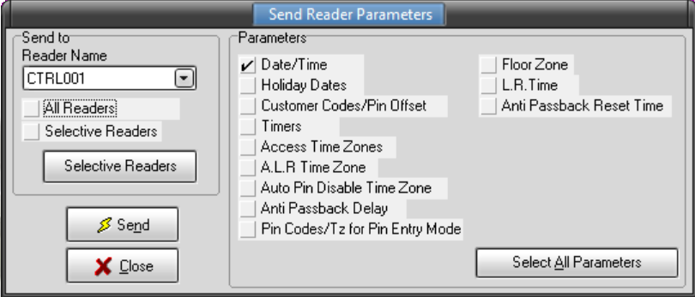

**Add Timers**

Timer is the range that you can assign to the time zones, so that each particular day in the time zone can be assigned with a set of time range. Timer would be the time each particular card can be access a door in a day.

Example: In: 07:00 Lunch Out: 13:00 Lunch In: 14:00 Out: 19:00

1. Go to Setup -> Timers
2. Click ‘Add’ button
3. Enter ‘Timer Name’, for example, office
4. Enter Start Time #1 (07:00) and End Time #1 (13:00)
5. Enter Start Time #2 (14:00) and End Time #2 (19:00)
6. Click ‘Update’ button to send the new timer to controller.

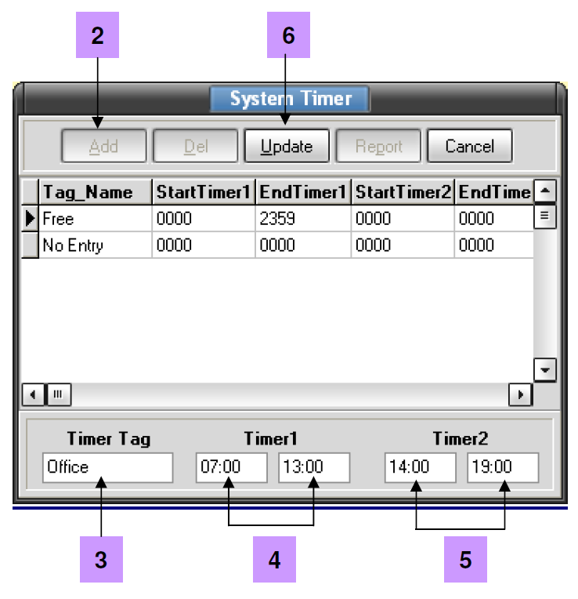

**Add Time Zone**

1. Go to Setup -> Time Zones
2. Click ‘Add’ button.
3. Enter time zone name in the field labeled ‘Time Zone Name’.
4. Move to the ‘Timer Tag’ field and select the timer from the drop-down list box.
5. Click ‘Update’ button to save record.

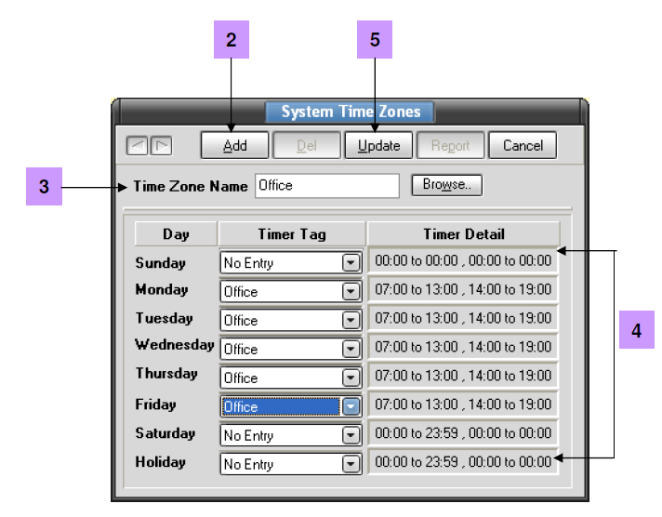

**Add Door Accessibility**

Door Accessibility holds particular controller and Time Zone that specific cardholders are allowed with access.

1. Go to Setup-> Door Accessibility.
2. Click ‘New’ button.
3. Insert Accessibility Category Name under New Accessibility screen.
4. Click ‘Update’ button.
5. Select reader name under Reader Name list.
6. Select time zone under Time Zone list.
7. Click ‘Add’ button to save into database.
8. If want to configure access time zone for another controller, repeat the process (5) to (7) again.
9. Click ‘Close’ button to send the new accessibility to the controller.

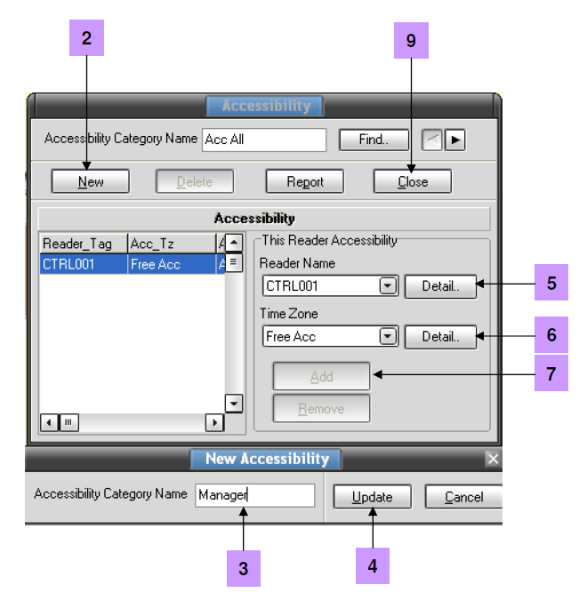

**Install User Card**

1. Go to Database -> Card Holder.
2. Click ‘Add’ button for new entry.
3. Enter ‘Staff No’, ‘Card No.’, ‘Staff Name’ and ‘Card’s start and expiry date’
4. Select the ‘Door Accessibility’, ‘Department’ and ‘Position’. The ‘Floor Accessibility’ is only valid for lift controller.
5. Click ‘Update’ button to send card to controller.

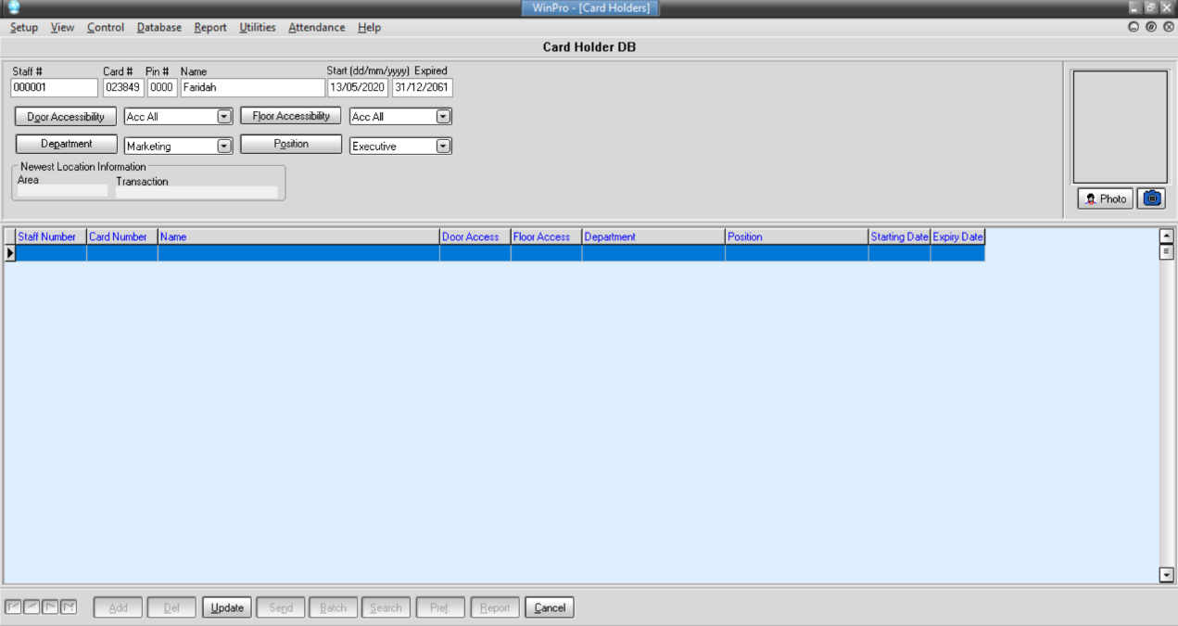

If you wish to add card by batch which have the same parameter (Door Accessibility, Floor Accessibility, Department, Position, Start and Expired Date), instead of one by one, then you may click on ‘Batch’ button then select ‘Batch Add’.

1. Enter the card number range to be added.
2. Select ‘Door Accessibility’ and ‘Floor Accessibility’
3. Select ‘Department’ and ‘Position’
4. Enter the card validity date (dd/mm/yyyy)
5. Click ‘Start’ button to add the card number into the card holder database.
6. After adding the card, at the card holder database, the ‘Name’ column will show ‘temporary’, you may edit the name and update to the database.

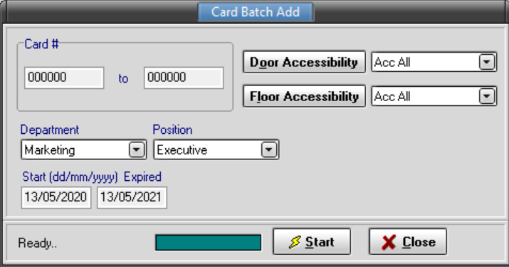

**Add Department & Position**

At card holder database,

1. Click on ‘Department’.
2. Click ‘Add’ button.
3. Enter the department name.
4. Click Save button.

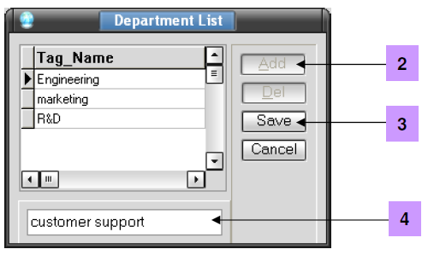

The procedure of add position is the same as department.

**How to enable Card + Pin mode**

1. Select Control -> Controllers
2. Select Send Control Signal

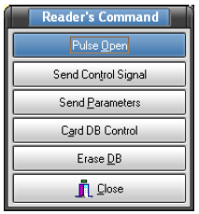

1. Select which controller to send you can send to only one controller, all controllers or selective controllers.
2. At Pin Mode column, click at ‘On’
3. Click ‘Send’ button.

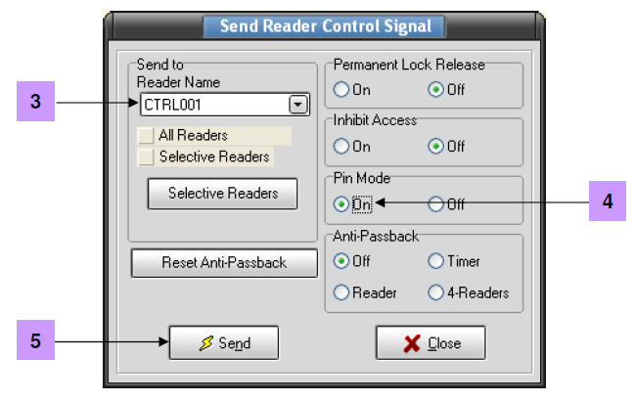

**How to activate Pin Disable Time Zone**

After you have enabled the Card + Pin mode, controller will prompt for pin at every card badge. You can also temporarily disable the card + pin mode for certain period by the using of time zone, that is PIN Disable Time Zone.

1. Create a time zone for disable the pin function.
2. Select Database -> controllers.
3. Select the relevant controller.
4. At the ‘Auto Pin Disable TZ’ column, select the time zone to disable pin.
5. Click ‘Update’

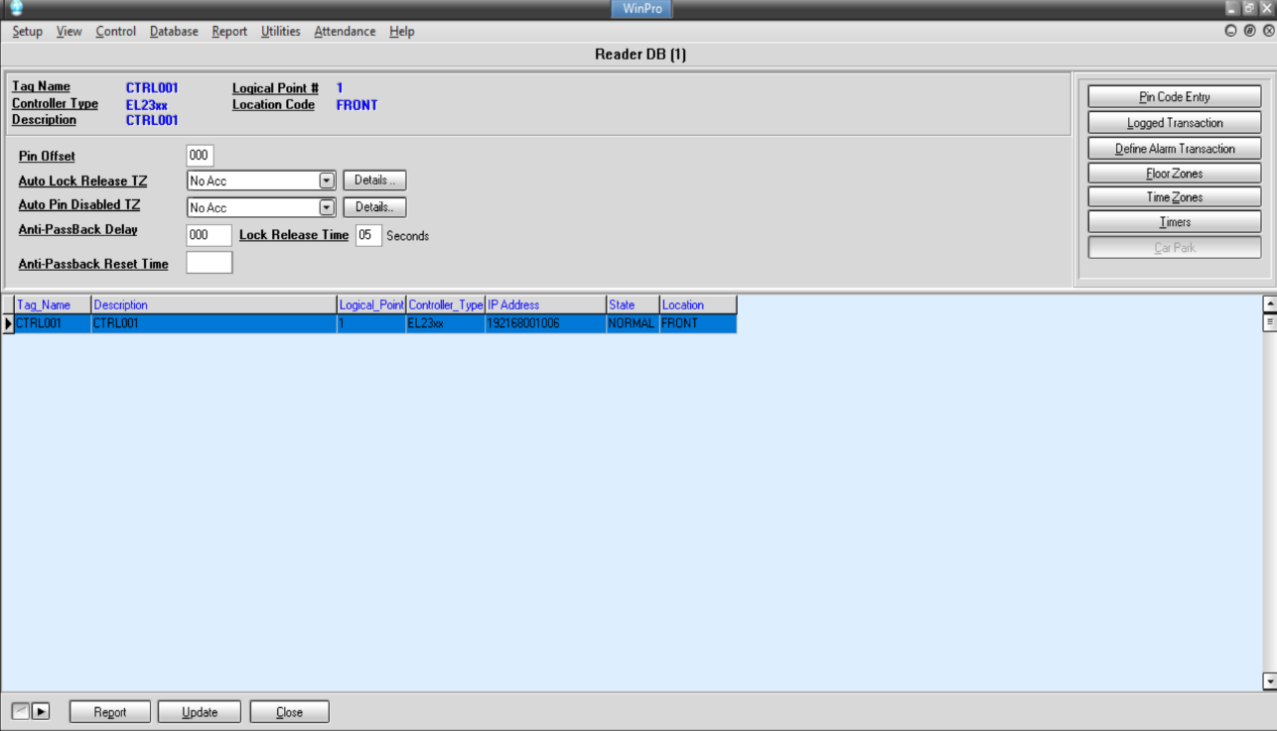

**4**

**3**

**5**

**View Access Report**

The access report allows you to check the history of entry and exit.

1. Click Report tab.
2. Specify the date of the transaction that you want to retrieve and print out.
3. Specify the sorting order of the transaction in the report.
4. Click the ‘Select Transaction’ button to choose the type of transaction to be printed out.
5. Filter the report. You can filter by Reader, Employee #, Card#, Name, Department and Job Title.
6. Click ‘View/Print’ button.
7. If you wish to print out the report, then you can just click at the ‘print’ button at the report preview screen.

